Herrera Elementary School Huskies
Leading the Pack

OUR MOTTO: Every Child, Every Class, Every Day – Doing what it takes!  THEME: Huskies United and Changing the Game  Herrera learners strive to be:  Principled Risk Takers Thinkers  Reflective Knowledgeable Inquirers  Open-Minded Balanced Caring  Communicators | THE HUSKY HERALD  January 2022  Principal: Mr. Carnes Assistant Principal: Mrs. Gutierrez
JANUARY IS:  - Get Organized Month  - National Mentoring Month  - National Thank You Month  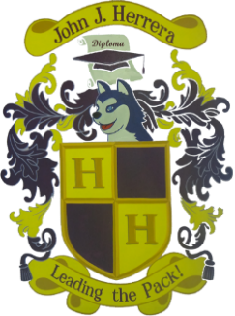  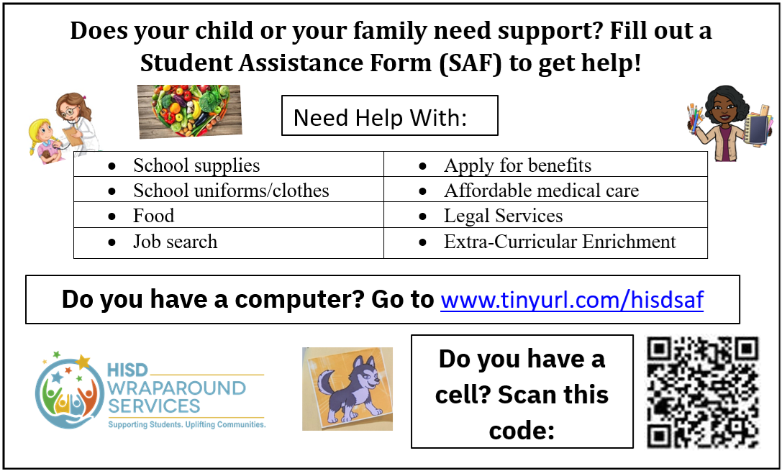 |  |  |  | REMINDERS  Please remember to have your child here on time and ready to learn.  Parents, please review, check for homework, and initial student agendas daily.  Check emails, website, and Twitter for important information.  Please send excuse notes home for absence(s) as soon as possible.  Home Connections and Social Emotional Learning Tips:  - Instilling a sense of organization and creating daily routines can help keep things organized easily. Some examples include using a checklist to prioritize tasks and organize time, completing chores that involve pre-planning, making a list, and organizing items, using a planner and establishing a homework routine.  - Consider mentoring someone! It can help build improved relationships, better communication skills, increased resilience and confidence, and enhanced social emotional development as well as self-reflection.  - Acknowledge people for all they do for you on a daily basis. Did you know that feeling thankful can help you feel better because of the feel-good chemical dopamine? Research shows that when we experience this goodness, we are more likely to engage in the thankful behavior again and again! Start a gratitude journal, take turns sharing who or what you are thankful for, write someone a thank you note/email…..do something nice! THANK YOU, students, staff, parents, and community for making Herrera great!
UPCOMING EVENTS:

January 12th Coffee with the Principal & Parent Workshop – parents must RSVP
January 17th Martin Luther King, Jr. Day – NO SCHOOL
January 18th Teacher Prep Day – NO SCHOOL
January 21st Report Card Day

